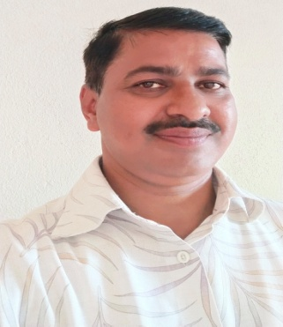

**Name:** Dr.S.E.Patil

**Designation:** Asst.Professor

* **Qualification:** M.Com, B.Ed, M.Phil, Ph.D
* **Area of Expertise:** Accounting and Finance
* **Experience:** 24 Years UG
* **Email ID:** saieepatil10@rediffmailmail.com
* **Phone:** 94213833677

Teaching Experience - 24 Years  
Research Paper published- 15  
Research papers presented are 10  
Conference, Workshop, Seminar attended are More than 50