**INDIVIDUAL PROFILE**

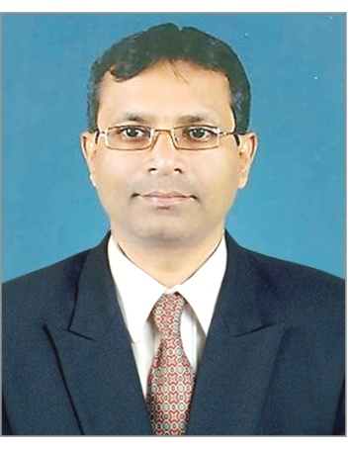

**1.Name –Dr. Bhupal Ramchandra Divekar**

**2.Department- English**

**3. Educational Qualification- M.A., M.Phil., Ph.D**

**4. Teaching Experience-29 Years.**

**5. Papers Published-10**

**6. Paper Presentation- 21**

**7.. Participation In**:

A) **Seminars: 13**

B) **Workshops: 19**

C) **Conferences -06**

**D) Training Prpogrammes- 06**

**8. . Orientation / Refresher/ Short Term Cources:10**