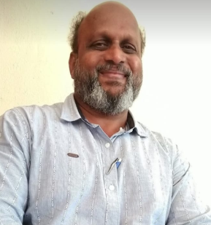**PERSONAL INFORMATION**

**NAME-** Dr.***Vijay Birappa Musai.***

**ACADEMIC** **QUALIFICATION**- ***M.A., M.Phil., Ph.D. [M.S.–CIT]***

**DESIGNATION WITH FACULTY** - **Head, Dept.of Sociology**.

**TEACHING EXPEERENCE-** ***24 Years in U. G .Level.***

**E MAIL I** [D](mailto:D-VIJAYMUSAI@REDIFFMAIL.COM)- [vijaymusaisoci@gmail.com](mailto:vijaymusaisoci@gmail.com)

**CONTRIBUTION TO CORPORATE LIFE**

* **HEAD-*Department of sociology***
* **CO-CO-ORDINATOR** ***-* *IQAC for Accreditation and Reaccreditation (2nd Cycle)***
* **PROGRAM** **CO-COORDINATOR**- ***Cultural Dept. for six years***
* **PROGRAM** **CO-COORDINATOR***-* ***Worked as******U.G.C’s Human Right Educations foundation course***
* **MEMBER -** ***L.M.C.*** **Local management committee (From-since 1997to 2016)**
* **EXAM.DEPT,SUK-** ***External Senior Supervisor*** **of shivaji university Kolhapur for six session**
* **SUBJECT EXPERT *worked as Subject expert*** **in sociology**
* **CO-COORDINATORExamination committee for four years**
* **CHAIRMAN/MEMBER Competitive exam. committee for three years.**

**RESEARCH ACTIVITIES**

* **M.Phil** – ***Mass Communication and Development: A study of Handewadi village, Dist. Kolhapur, Maharashtra***.
* **Ph**.**D.** - ***A study of Atrocities on Dalit Women in Kolhapur District.***
* **PUBILICATION *- 9 research papers are published***
* **RESEARCH PAPERS -*61 Research papers presented and participated in International, National ,State, Local level.***

**MEMBER OF ACADEMIC BODIES** –

### *Life member ,Indian Sociological Society*

* ***Life member ,Marathi samaj shastra parishad..***
* ***Life member, Shivaji Vidhyapeeth Samaj Shastra Parishad Kolhapur.***
* ***Life Member, Shivaji University Teachers Association***
* ***Member of S. J. Social and Development Foundation ,Kolhapur***

**MEMBER OF SOCIAL BODIES -**

* ***Member ,Prabhodhan Jyoti ,Kolhapur.[Ichalkrangi]***
* ***Member ,D.N.V.P. Gadhinglaj. Dist. Kolhapur.***
* ***Former Director,Ravalnath Housing Financial Credit Society Ajara .Dist Kolhapur .for five years (2010-15 )***