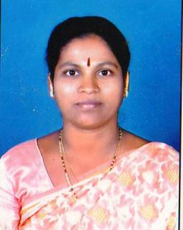INDIVIDUAL PROFILE

* Full Name : Sou. Lokhande Sangita Kiran
* Date of Birth : 10,June,1973
* Caste : Hindu ,Mahar (SC)
* Gender : Female
* Education Qualification : M.A , B.Ed. , M.Phil,(History)
* Date of Joining : 28th Sept.1999 , T.K.Kolekar Arts & Commerce College,Nesari.
* Designation : Assistant Professor.
* Teaching Experience : 22 years
* Residential Address : “GURUMAULI NIWAS” Plot NO22,Sadguru

Colony,SunderNagar,Nesari,

Tal.Gadhinglaj, Dist.Kolhapur PIN.416504

* Email Address : [sangitalokhande10@gmail.com](mailto:sangitalokhande10@gmail.com)
* Participation in Workshop : 36 Times.
* Paper Published : 5 Papers Published in Reputed Journals with ISSN Numbers.
* Participaton & Paper : 5 ,INTERNATIONAL,20, NATIONAL LEVEL SEMINAR AND

Presentation WORKSHOPS.

* Resource Person : 8 Times on Various Dias.