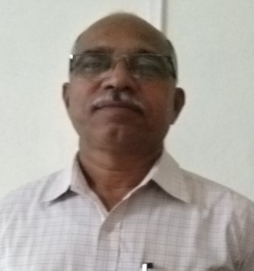**PERSONAL PROFIL**

**Name:.** CHOUGULE SADASHIV BALU

**Designation:**Asst.Prof

**Teaching Experience:** 22 years

**e.mail I.D** sbchougale1166@gmail.com

**Contribution to Corporate life:-**

* Head:- Dept. of Commerce & Management
* Programme Officer:- National Service Scheme(NSS)

**Rearch Activities**

* M.Phil-. Commerce
* Ph.D :- RegistrAtion
* Publication: 6
* Research Paper: 38 Research Papers are Presented & Participated in National & International Conference, Seminar.

**Member of Academic Bodies:-**

* Life Member of All India Commerce Association
* Life Member of SUCOMATA (Shivaji University Kolhapur)
* Member: - BoS in Commerce (S.U.Kolhapur)

**Member of Social Bodies:-**

* Member of Prabodhan Prakashan Jyoti (monthly)
* Honorary Secretary:- Shikshan Samiti Employees Co-op Credit Society, Nesari