**Personal Information** 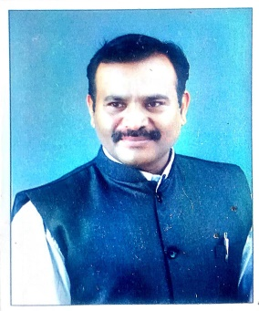

**NAME :- DR. KOLASEKAR MANOHAR SUBRAV**

ACADEMIC QUALIFICATION :- **M.A, M.PHIL, PH.D**

DESLGMATION WITH FACUITY :- **HEAD, DEPT. OF HISTORY**

TEACHING EXPEERIENCE :- **UG. 24 YEARS**

**Email ID :-** [manoharkolasekar@gmail.com](mailto:manoharkolasekar@gmail.com)

**Blogger ID** :- https://shivpratapitihas.blogspot.com

**Contribution To Corporate Life**

|  |  |  |  |
| --- | --- | --- | --- |
| **Sr.No.** | **Name of the bodies** | **Designation** | **Year** |
| 1 | Department of history | Head | Since -1997….. |
| 2 | N.S.S | Head (Co-ordinator) | 4 years |
| 3 | Internal Educational Evaluation Exam Department | Head | 4 years |
| 4 | Local management Committee | Member | 1997 To 2007 |
| 5 | Educational tour | Head | 2007-2016 |
| 6 | Time- table Committee | Head | 2006-2007 |
| 7 | Cultural activates | Head | 2006-2007 |
| 8 | Sports committee | Member | Since -2008…… |
| 9 | Proad & niranthan vibhag | Head | 2010 to 2012 |
| 10 | Balwadi shikshika coursa | Head | 2010 to 2012 |
| 11 | Naac committee, VI Criteria | Member | Since …2013 |
| 12 | Exam Dept., SUK | Membe | Since….2021 |
| 13 | Magazine Committee | Head | 2021 To…. |
| 14 | Subject expert In History | University level | Nine Time |
| 15 | Staff secretary | Head | Since… 2007 |
| 16 | UGC Network Center | Head | 2011 to 2012 |
| 17 | Shivaji University History Association | Member | Life time |
| 18 | Satara History Association | Member | Life time |
| 19 | Maharashtra itihas prishad | Member | Life time |
| 20 | Life member SUTA and MUST Teacher Association | Member | Life time |
| 21 | Founder & Adviser for Shri Kaiamma Dudha Sanstha Lakurwadi | Member | Life time |
| 22 | Sarvjanik vacnalay Nesari & Lakurwad | Member | Life time |
| 23 | Blood Donation (4 Times) |  |  |

**Research activities.**

|  |  |  |
| --- | --- | --- |
| **Sr.No** | Name of Degree | Title |
| 1 | **Ph.D** | Social, political, education and cultural contribution of daily tarun bharat ( A.D 1919 to 1980) |
| 2 | **M.Phil** | Bhai Dajiba Desai Life and Works |
| 3 | **Minor research Project** | Maharashtra Karnataka Border Dispute and agro Tax Resistance Movement in Belgaum District |

**Research papers**

**49, Resarch Paper Presented and Participated In State , International and National**

International level Paper publication :- **08**

National level Paper publication **:- 18**

**State level Paper Publication :- 10**