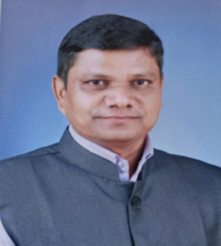 **PERSONAL PROFILE**

**NAME** : SASANE JAGADEESH KESHAVRAO

ACADEMIC QUALIFICATION : M.A. SET (SOCIOLOGY)

**DESIGNATION WITH FACULTY**: AAISIT. PROF. DEPARTMENT OF SOCIOLIGY

TEACHING EXPEERIENCE : 16 YEARS

Email: jsasane50@gmail.com

**CONTRIBUTION TO CORPORATE LIFE:**

* HEAD, UGC COMMITTEE (2014- 2021)
* HEAD ADMISSION COMMITTEE (2018-2021)
* HEAD, CULTUTAL COMMITTEE (TWO YEARS)
* MEMBER, CULTURALCOMMITTEE ( 3 YEARS)
* MEMBER/ WALL PAPER COMMITTEE
* MEMBER - MARATHI SAMAJSHASTRA PARISHAD,

MEMBER - SHIVAJI UNIVERSITY SAMAJSHASTRA PARISHAD KOLHAPUR,

MEMBER- INDIAN SOCIOLOGICAL SOCIETY, MEMBER-

* LIFE MEMBER FASTA
* WORKED AS A SUBJECT EXPERT (1 TIMES) LOCAL COLLEGE,PATANE FATA INTERVIEW
* PARTICIPATION IN UNIVERSITY ASSESSMENT WORK.
* ASSOCIATE EDITOR BOARD , SHODHYATRA KHAND 8 ISBN 978-81-925656-3-7

**RESEARCH PAPERS : 19**

**INTERNATIONAL LEVEL PUBLICATIONS : 8**

**NATIONAL LEVEL PUBLICATIONS : 11**

**------------------------------------------------------------------------------------------------------------------------------------------------------------**