SELF PROFILE 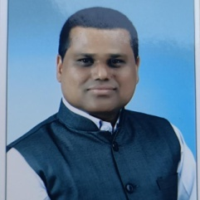

* Full Name: Dr. Dattatray Keraba Kamble
* Date of Birth: 01-06-1977
* Gender: Male
* Education Qualification: M.A.,B.Ed.,M.Phil.,Ph.D. (English)
* Date of Joining: 01-06-2007, at T.K.Kolekar Arts and Commerce College, Nesari , Tal: Gadhinglaj , Dist: Kolhapur
* Designation: Assistant Professor
* Teaching Experience: 14 years
* Residential Address: A/P: Karanjivane, Tal: Kagal, Dist: Kolhapur

Mob. No. : 7775934288

* Email Address: [dattatrayk1977@gamil.com](mailto:dattatrayk1977@gamil.com)
* Participation Workshop: 17
* Paper Published: 13
* Participation and Paper Presentation: 24
* Resource Person: 6