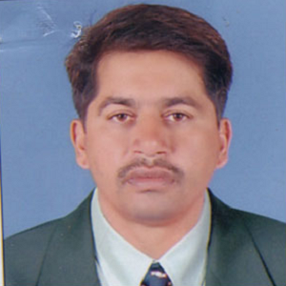

Kanchan Baburao Bellad

Director Of Physical Education & Sports